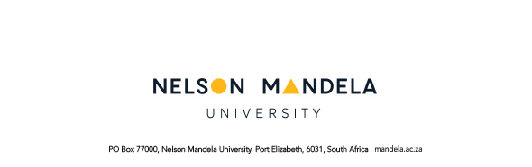
FACULTY OF LAW
3rd Annual Conference for Emerging Scholars
6 November 2017
CONFERENCE REGISTRATION FORM
R450.00 – Payable by 20 October 2017
TITLE |  |  |  |  | SURNAME
INITIAL(S) |  |  |  |  | FIRST NAME
ID/PASSPORT NUMBER

UNIVERSITY/ INSTITUTION

EMAIL ADDRESS

TEL NUMBERS |  |  | (work |  |  |  |  |  | (mobile)
POSTAL ADDRESS

POSTAL CODE

COUNTRY

PROFESSION (TICK APPROPRIATE BOX)
Academic
Attorney
Advocate
Student
Other

If you answered other, please specify:_____________________________________
DIETARY REQUIREMENTS (TICK APPROPRIATE BOX)
Kosher
Halaal
Vegetarian
Normal
Other

If you answered other, please specify:_____________________________________
CONFERENCE DINNER 21 AUGUST 2017
Will attend
Will not attend

CONTACT DETAILS OF NEXT OF KIN IN CASE OF EMERGENCY
Name
Relation
Number 1
Number 2

HOW DID YOU HEAR ABOUT THE CONFERENCE? (TICK APPROPRIATE BOX)
Email
Institutions website
Word of mouth
Other
If you answered other, please specify:_____________________________________

